Problem No: 1

Problem Statement:
Write a MATLAB program to compute and plot the linear convolution of two discrete-time sequences, x1(n) and x2(n), provided as user inputs. The program should display the resulting convolution sequence in the command window and generate a multi-panel figure containing stem plots for both input sequences and the convolution output.

Codes:
clc; clear; close all;
A = 1; f = 5; t = 0:0.001:1;
y = A * sin(2pif*t);
figure;
plot(t,y);
grid on;
title("Sine wave");
xlabel("Time (s)");
ylabel("Amplitude");

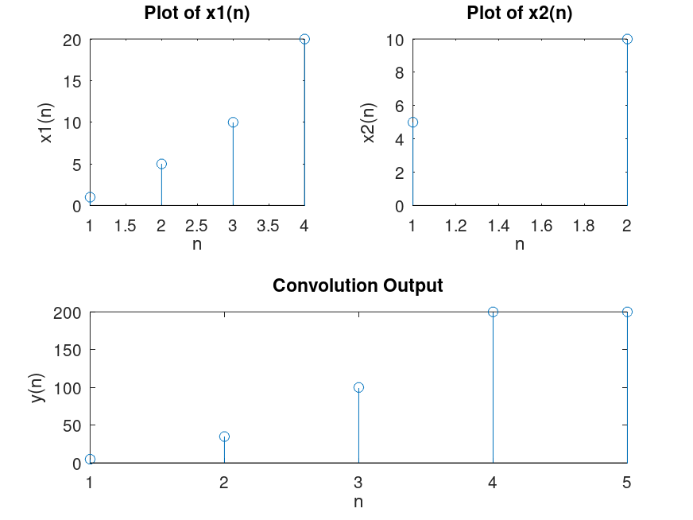
Output:

